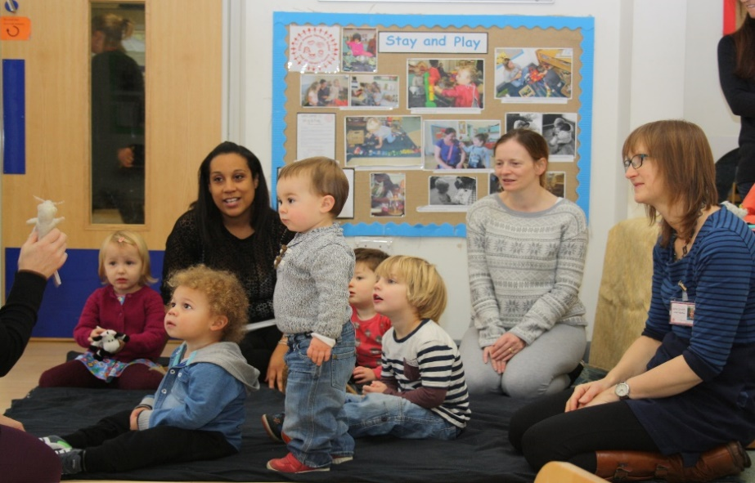
Childminder Groups:
Best Practice Tips for Settling-in New Children
‘Taking a child who you don’t know very well to a group they have never been to before can be very daunting for the child. They need to have built up a strong enough attachment/ relationship so they can pick you out in a crowd. This helps them to feel safe.’ Bristol Childminder
- Wait until the child or baby is really settled and knows you well before bringing them along to a childminder group.
- Prepare the child for coming to the group. Remember they don’t know the adult running the group or what will happen at a group. It might help if you explain the routine of the group for an older child.
- If your baby or child becomes distressed in the group, try to look for a quiet space to comfort them. Another childminder or the person running the group might be able to watch your other children so you can concentrate on soothing an upset child or baby.

‘Children and babies need continuity and a sense of belonging. They need to be sure of who their care provider is. Allow time for the child to bond with the childminder before taking him/her to groups so they know, in a room full of adults, which adult is theirs’. Bristol Childminder

- Childminder groups are great places for getting advice and support but do be careful about talking about the child or their family in front of them.
- Remember that the childminder group is part of the local community and so it’s important not to share sensitive information about a child or their family with other childminders.
- Do let the group leader know if you have a new child settling in so both they and the other childminders can be aware of this and support you.
- You might consider just coming for the free play part of the group at first, leaving before the snack and story time until you feel the child/baby is ready for this.
‘For the new child’s first two or three sessions I will stay at my house, so that they can begin to get to know me and their ‘second home’. After these initial sessions I usually find that as long as I am offering the baby/ toddler as much closeness as they need, they can often cope with our usual routine of going out playgroups or similar’. Bristol Childminder

