Books about starting school
(Adapted from lists by Emily Guille-Marrett Top 8 books about starting school | Oxford Owl and the Book Trust Starting School | BookTrust

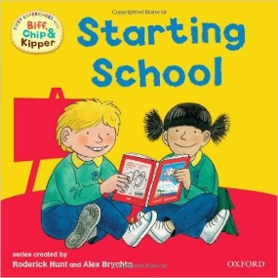

Biff, Chip and Kipper - Roderick Hunt & Alex Brychta
From finding his peg to painting a picture and making friends to losing his teddy, a lot happens to Kipper on his first day.

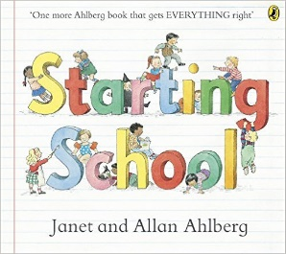
Starting School - Janet & Alan Ahlberg
A number of children’s first experiences are followed in this now classic picture book – from their first day through to the end of the school year. Various emotions are sympathetically explored so every reader can find things to identify with.

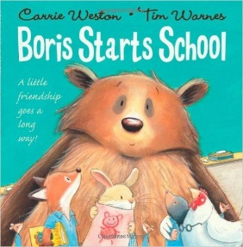
Borris starts school - Carrie Weston & Tim Warnes
Throughout Boris’s first day of activities, from reading and writing to lunch, play and home time, things just seem to go wrong for him. Being large, hairy and a little bit grizzly, Boris doesn’t mean to scare all the other animals at school; he just wants to make friends. Then something unexpected happens and Boris becomes a class hero.

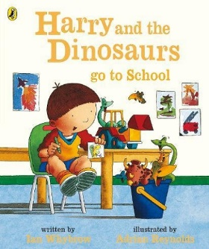
Harry and the Dinosaurs go to school - Ian Whybrow & Adrian Reynolds
Harry and his bucketful of dinosaurs experience being separated for a time in the classroom. Although there are lots of fun things for Harry to do at school, like make new friends and play on the monkey-bars at breaktime, he just wishes he could be with his dinosaurs. Then things start looking up for Harry. The teacher doesn’t mind it when the dinosaurs let out a big roar. And a little boy who hasn’t uttered a word all day is so inspired by Harry’s prehistoric pals, he tells a dinosaur joke in front of the whole class. School can be fun– for children and dinosaurs!

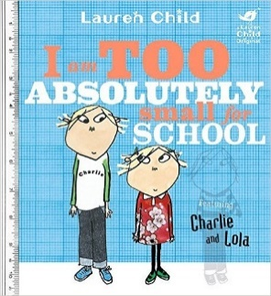
Charlie and Lola: I Am Too Absolutely Small For School -
Lauren Child
This book follows Lola as she deals with her thoughts and feelings about starting school. Big Brother Charlie is full of advice and responds tirelessly to his little sister’s endless reasons for not needing to go to school. And the relationship between Lola and her imaginary friend are sensitively explored as the big day gets nearer. Of course, at the end of a successful day at school, it was always her imaginary friend Soren Lorenson who was nervous – and not Lola!

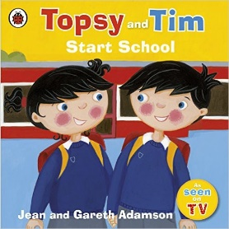
Topsy and Tim start school - Jean & Gareth Adamson
Many children can relate to these famous characters and follow them through their busy school day – from the classroom to the playground and canteen. In true Topsy and Tim fashion, we learn at the end of the story that school can be fun.

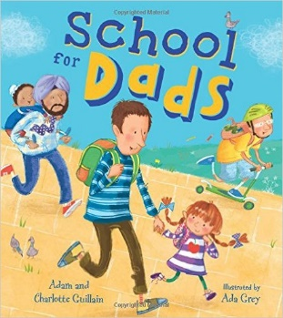
School for Dads - Adam & Charlotte Guillain; Illustrated by Ada Grey
Little Anna is fed up with her father always being late for school pick up. But then roles are reversed and it’s the dads who have to go to school run by their children. This book is a refreshingly light-hearted way to introduce children to the concept of school and how fun it can be.

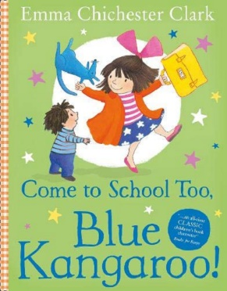
Come to school too Blue Kangaroo - Emma Chichester Clarke
This book is a gentle and imaginative way of exploring school. It works well for children who are either starting school for the first time or moving to a new school. A classic picture book character, Blue Kangaroo is Lily’s special toy. He responds to her thoughts and feelings throughout Lily’s starting school journey. The adventures really begin for Blue Kangaroo when he gets left in the classroom overnight. By exploring his night time antics, readers get to experience the classroom in a magical

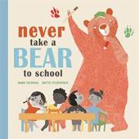
Never take a bear to school – Mark Sperring
If it's your first day of school and you're feeling a little sad or afraid, but you still cannot take a bear with you. There are some very good reasons for this: he'll cause panic by running through the playground, waving his claws; he'll growl, he won't fit into the chairs, he'll eat all the food at lunchtime. But don't worry: you'll have a wonderful time with all your new friends, and when the end of the day comes, Bear will be waiting with a big hairy hug.
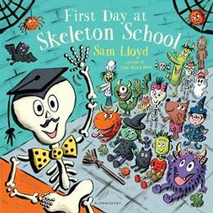
First day at Skeleton School – Sam Lloyd
There's a creepy night time school in the forest that you might not know about: Skeleton School! There are a haunted library and zombie chefs cooking beetle burgers for lunch, and all manner of zany happenings with Wizard Wilfred magicking frilly knickers onto Mr Bones. Yet, at the end of the school day, the children hear a truly terrifying noise: little boys and girls on their way to Human School!
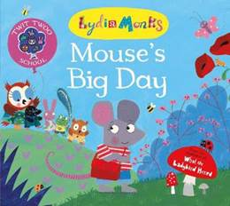
Twit Twoo School: Mouse’s Big Day – Lydia Monks
A gentle and sensitive book exploring fears that might surround starting school or nursery

Mae’s First Day of School – Kate Berube
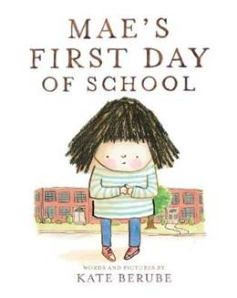
It’s Mae’s first day of school, but she doesn’t want to go, despite all her mother’s excitement about class pets, big libraries and long playtimes. Instead, Mae worries: what if the other kids don’t like her, what if she doesn’t understand what to do, and what if she misses her mother? Rather than follow the rest of the children inside when it’s time to start the day, Mae climbs a tree and refuses to come down. She’s soon joined by Rosie, who has similar worries, and a tall lady called Ms Pearl. Ms Pearl is worried that her pupils might not like her – and what if she spells Tuesday wrong when she writes it on the board? Maybe they should all live in the tree instead.
This book acknowledges the anxiety that children might have about starting school, but reassures them that they’re not the only one with such worries.
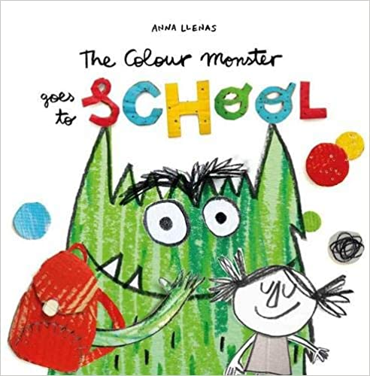
The Colour Monster Goes to School
Anna Llenas's popular Colour Monster is back, and this time he's heading off to school! But what exactly is school? A spooky castle filled with terrifying animals? A place in the sky, amongst the rainbows and clouds? From music lessons, to lunchtime, to making new friends, the Colour Monster's first day of school is filled with exciting new adventures.
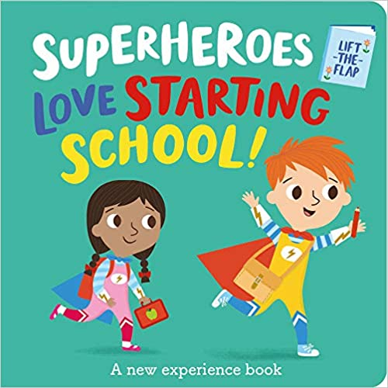
Super Heroes Love Starting School
How do superheroes start their first day? Do they learn new things and make new friends? By lifting the flaps to choose what happens next on each page, children help the superheroes learn all about going to kindergarten in a reassuring and interactive way. This book is perfect for children who are taking their first big steps towards starting school with confidence.
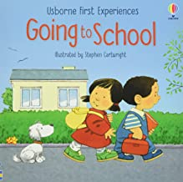
Going to School
This book gently introduces young children to the idea of going to school for the first time. The simple, reassuring text explains what to expect, and the charming illustrations by Stephen Cartwright are full of fun details to look at and talk about together.
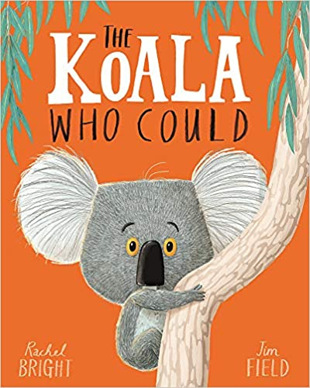
The Koala Who Could
Meet Kevin. A koala who likes to keep things the same. Exactly the same. But sometimes change comes along whether we like it or not... And, as Kevin discovers, if you step outside your comfort zone and try new things, you might just surprise yourself!

