
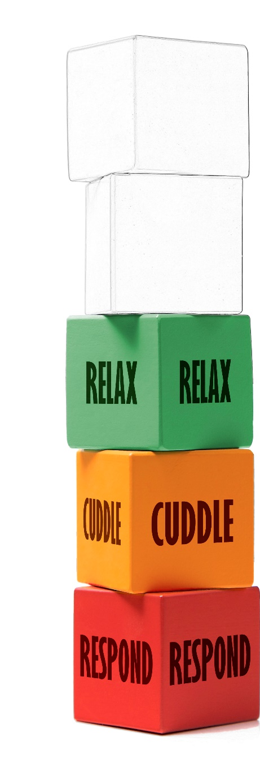
RELAX
TRANSITION

For Settings
- Plan relevant well-being CPD for Practitioners to be emotionally available to families eg: Five to Thrive, ACT (Acceptance Commitment Training) and TIS (Trauma Informed Practice/Schools/Communities).
- Before and after key transitions create ‘wind down’ times to enable children to know what is happening and feel relaxed.
- Prepare children in advance of transitions by using visual timetables or songs to help them anticipate transitions.
- Build in familiar activities for children to prepare fully for transitions and create the conditions to enable children to relax eg: sing songs, music, rhythmic movements and using soothing voices.
- Tune into the routine of the day and make decisions about where children would benefit from planned opportunities to relax eg: a busy/ physical morning my need a longer calming time before a transition to lunch.
- Model how to relax and how to regulate emotions throughout the day eg: enjoy the importance of stopping and standing still, share mindfulness techniques, breathing exercises (blowing bubbles), yoga stories (Dear Zoo), walking and noticing surroundings.
- Encourage outdoor play – ensure the outdoor environment supports children’s connection with nature and their awe and wonder of the world, so that they achieve deeper levels of relaxation and mindfulness eg: watching the clouds, feeling the wind on your face, notice grains in wood.
- Encourage children to learn strategies to calm themselves during transitions eg: notice the ‘breath’; how it affects our internal state, how it changes depending on the activities we do such as if upset- breathing is fast and shallow, when relaxed- breathing is deep and slow, after exercise- it is fast and deep.
- During transitions, co-regulate with children; calm yourself, model a relaxed tone of voice and body language; this will encourage children to do the same.
- Consider the indoor and outdoor environments and whether improvements can be made to make it more calm, relaxed and welcoming eg; using natural materials, lessen bright/ bold colours, soft lighting etc…
- Support children to regulate and channel their energies and emotions in a positive way during transitions eg: physical movement, routine songs/actions and music.

RELAX
TRANSITION

