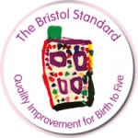 Bristol Standard Validation results 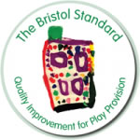
January 2024
The following settings were successfully validated:
Bristol:
Red Bus Nursery and Pre-School (Coombe Dingle)
Bishopston Beanstalks
Brislington Village Pre-School
Little Foxes Forest School
Bristol University Day Nursery
Fallodon Playgroup
Peter Pan Nursery

Play settings:
School’s Out Henleaze
Knowle Park After School Care

Wiltshire
Urchfont Pre-School

