Peep Learning Together Programme (LTP)

Bristol Family Hubs are excited to announce Peep LTP Training
Peep LTP Training is for practitioners who work with parents/ carers and babies/ young children, to contribute to:
- strong parent-child relationships,
- increased parental knowledge and confidence in how to support their child's learning and play in day-to-day life,
- children’s personal, social & emotional development, communication & language, early literacy, early maths, and health & physical development.

After the success of previous training sessions, we have been fortunate to be able to offer additional training on:
- Wednesday 26th and Thursday 27th June 2025
Training will take place at Engineers House, 9.30am – 4.30pm each day.
The training equips practitioners to:
- engage and support parents to build on what they already do to enhance their child's early learning and communication (contributing to school-readiness), through talking and playing as part of everyday life,
- explore practical ideas, strategies and resources, using the comprehensive and flexible Peep Learning Together Programme,
- deliver universal or targeted sessions with parents and children together – in person or online: in groups or drop-ins.

Trained practitioners will receive the programme folder containing all topics covered, Peep Singing together songbooks and £500 to put towards resources to get your sessions up and running.
Settings will receive £500 to cover the costs of releasing practitioners.

Click here to book a place:
https://www.eventbrite.com/e/866119967137?aff=oddtdtcreator

Peep Learning Together Programme (LTP) Training: Overview for Practitioners
Aims:
This 2-day Training gives you online access to the Peep Learning Together Programme, which helps to improve young children's outcomes and to narrow the gap in educational attainment by working with parents.
The evidence-based Learning Together Programme (LTP):
- is for using with parents/ carers and their babies or young children, contributing to strong relationships and support networks between parents, children and practitioners,
- values and extends parental knowledge and confidence in how to support their child's learning and play in day-to-day life (contributing to transitions into nursery or school),
- provides a fun way of working with families, focusing on simple, free or low-cost activities which support the home learning environment - talking, singing, sharing books and playing together,
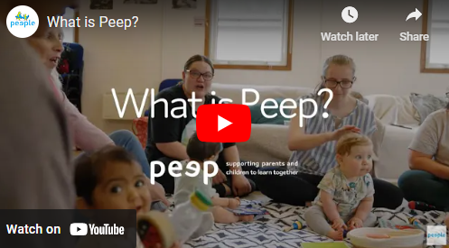
- contains 74 child development topics, each with session plans and parent handouts (which you can print or share online). The topics cover Personal, social & emotional development, Communication & language, Early literacy, Early maths, and Health & physical development,
- can be delivered flexibly, to suit your local needs and interests:
  - you can use any number of the topics in any order,
  - you can deliver it in universal or targeted sessions,
  - you can use the Programme indoors, outdoors, or online, and in groups, drop-in/ stay and play sessions, or 1-to-1,
  - you can offer parent qualification units through the Peep
Progression Pathway, with an extra day of training.
> Watch our 4-minute video to hear from Peep parents and practitioners
LTP Training (2-day):
During the training: You will explore practical delivery ideas, strategies and resources, using the Learning Together Programme. The training values and builds on delegates' knowledge, skills and experience.
Who for: The training is for practitioners from any sector who work with parents/carers and/or babies or young children. This has included staff and volunteers in children's and community centres, family hubs, education and childcare settings, colleges, health and social care settings, libraries, prisons, museums, stay and play or parent and toddler groups, outreach - anywhere that involves working with families.
How delivered: Face-to-face or live online. If online, we post you a delegate pack beforehand.
Post-course delivery support: On-going access to the Programme resources and delivery support guidance via our login website, a Peep practitioner Facebook group, practitioner newsletter and podcast, and a growing network of local Peep champions.
Practitioner Accreditation (optional, small extra charge to cover support, assessment, and certification): a 3-credit unit at level 6 (Scotland) or level 3 (rest of the UK), contributing to CPD and quality assurance.

